C Sharp assignment #2

Assignment to get a basic idea about class/object creation, Constructors, and static elements.

Topics covered:

1. Creation of Class
2. Constructors
3. Static keyword

Description:

1. Create a Student class as represented in below class diagram.

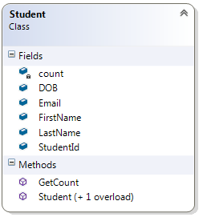

Create all fields as public and a static variable count.

1. Create two constructors one default/ parameter less constructor and another parameterized constructor which takes all field values and initializes them.
2. Create a method GetCount, which returns a total number of students created so far.
3. Create some students objects and initialize them using constructor/ directly assigning the values.
   1. Student ID should be assigned automatically (starting from 1000 and incremented by 1 every time).
4. Print created student details, Finally, print the total number of students created by calling GetCount.

Hint: Use a static variable to keep track of students count and to automatically assign studentID.